**Project Design Phase-II**

**Data Flow Diagram &User Stories**

|  |  |
| --- | --- |
| Date | 03October 2022 |
| Team ID | PNT2022TMID50120 |
| Project Name | Inventory Management System for Retailers |
| Maximum Marks | 4 Marks |

**Data Flow Diagrams:**

A Data Flow Diagram (DFD) is a traditional visual representation of the information flows within a system. A neat and clear DFD can depict the right amount of the system requirement graphically. It shows how data enters and leaves the system, what changes the information, and where data is stored.

**Example:** [**(Simplified)**](https://developer.ibm.com/patterns/visualize-unstructured-text/)

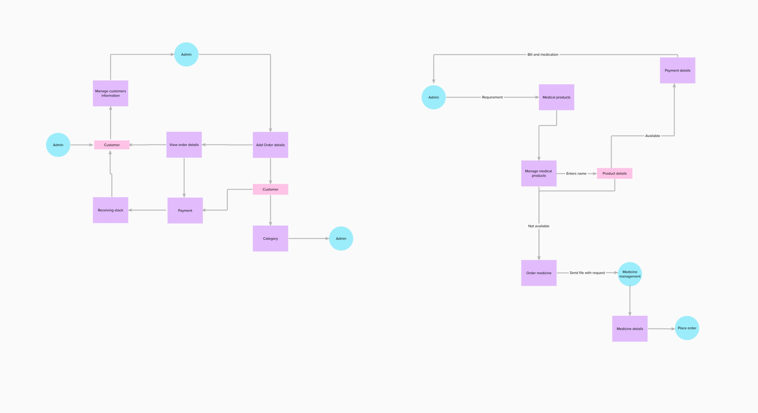

**User Stories**

Use the below template to list all the user stories for the product.

| **User Type** | **Functional Requirement (Epic)** | **User Story Number** | **User Story / Task** | **Acceptance criteria** | **Priority** | **Release** |
| --- | --- | --- | --- | --- | --- | --- |
| Customer (Mobile user) | Registration | USN-1 | As a user, I can register for the application by entering my email, password, and confirming my password. | I can access my account / dashboard | High | Sprint-1 |
| USN-2 | As a user, I will receive confirmation email once I have registered for the application | I can receive confirmation email & click confirm | High | Sprint-1 |
| USN-3 | As a user, I can register for the application through Facebook | I can register & access the dashboard with Facebook Login | Low | Sprint-2 |
| USN-4 | As a user, I can register for the application through Gmail | I can register & application  Through Gmail | Medium | Sprint-1 |
| Login | USN-5 | As a user, I can log into the application by entering email & password | I can access my account | High | Sprint-1 |
| Dashboard | USN-6 | As a user,i can log into my account for the mobile | I can access my account /Dashboard | High | Sprint-1 |
| Customer (Web user) | Registration | USN-7 | As a user,I can register for the application by entering my email, password, and confirming my password | I can access my account/Dashboard | High | Sprint-1 |
| USN-8 | As a user, I will receive confirmation email once I have registered for the application | I can receive confirmation email & click confirm | High | Sprint-1 |
| USN-9 | As a user, I can register for the application through Facebook | I can register & access the dashboard with Facebook Login | Low | Sprint-2 |
| USN-10 | As a user ,I can upload a Profile photo and add my name to my account | I can upload my Profile photo/Name in my account | Medium | Sprint-1 |
| Customer Care Executive | Customer Support | USN-11 | As a user,I can support for customers to handle queries and complaints from their customers | I can support for customers to clear complaints | High | Sprint-1 |
| Administrator | Responsibility | USN-12 | As a system administrator I want to be able to add new users when required so that | I Can add new users | High | Sprint -1 |